System requirement specification (SRS)

# Scope

The system we are working with is the automatic levelling header on a combine.   
This consists of several different mechanical/hydraulic components.

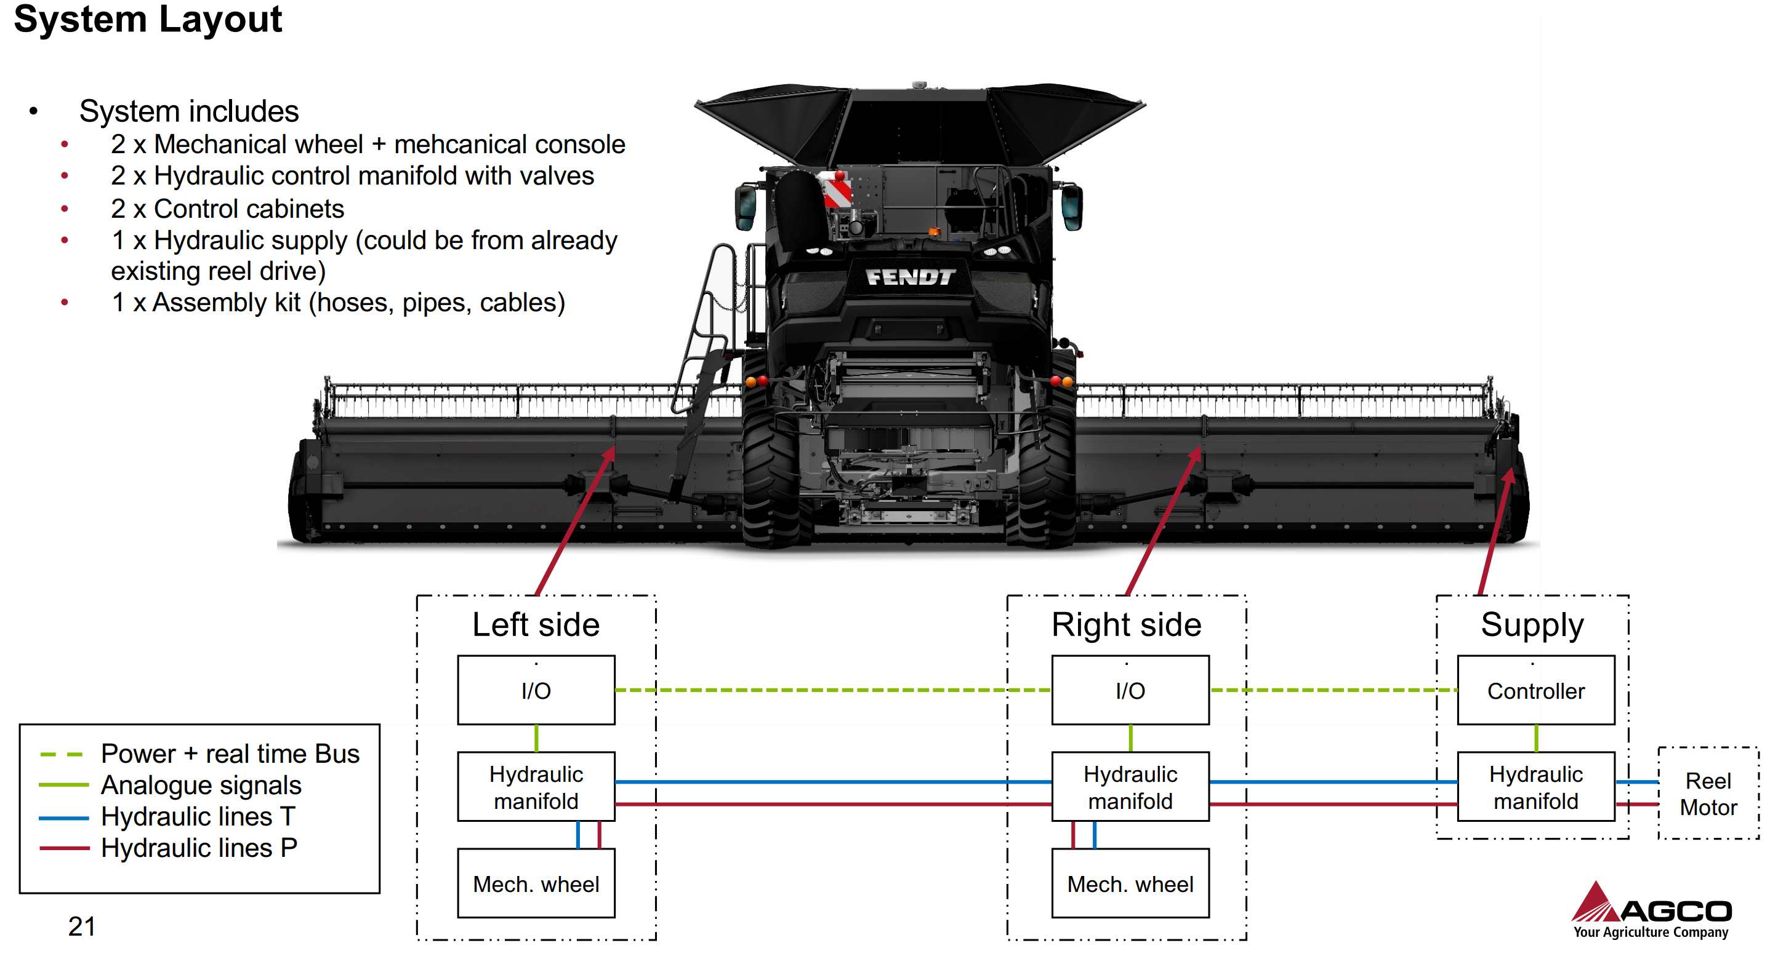

These parts are called the Auto Header Height Control system (AHHC) and controls the position of the header when harvesting.

This system has three measurement parameters that the system can control.

Lift angle $θ_{1}$ which provides the desired stubble height.   
Pitch angle $θ_{2}$ which provides the desired cut angle  
Tilt angle $ϕ_{1}$ which is the side-to-side angle, normally used to provide clean cut on side-hill condition.

$ϕ_{1}$ is the parameter that our system will control and make sure that the system does not oscillate when on uneven fields as it leads to poor performance.

The current system has problems with slow response, position overshoot, and oscillations due to instability.

Our system is an add-on to the AHHC-system that improves the performance on uneven fields.   
This will not be a hardware change, but a solution that adds to the AHHC systems and fixes the inherent hardware issues in the hydraulic control system.

The system will consist of a wheel on the either side of the header. This wheel is position controlled by hydraulic actuators.   
The system will contain sensors for height and cylinder pressure.

# Requirement descriptions and Quality provision

|  |  |  |  |
| --- | --- | --- | --- |
| **Requirement category** | **Req. id** | **Requirement description** | **Quality provision method** |
| **Required states and modes** | R1 | There are two modes that the system should operate in: the harvesting mode and the transportation mode | Demonstration of switching between modes |
| R2 | In harvesting mode, the system should stabilize the header on an uneven field. | Demonstration |
| R3 | In transportation mode, the system should be compact enough not to interfere with the loading onto the header trailer and fit within the width limits set by the EU for transporting trailers. | Analysis. The width of the installed system should be analysed. |
| **System capability** | R4 | The wheels and structure should be able to **handle a load of 500 kg**. | Testing of prototype system |
| R6 | System shall be of at least **IP66 protection rating**. | External testing firm verification |
| R7 | Operator shall be able to **enable and disable wheels** from cabin. | Demonstration with mounted prototype system |
| R8 | The system should have sensors that allows it to maintain a constant cylinder pressure and control the wheel position. | Testing of prototype system to see if sensor can regulate correctly |
| R9 | Wheel actuators shall be able to move wheels such that **header is kept level when passing a height increase of 150 mm** at the right side of the header **driving 8 km/h**. | Testing of prototype system |
| R10 | Tires may **maximum sink 30 mm** into soil. | Testing of prototype system |
| R11 | Maximum stress on the soil in the contact area from the tires **should not increase 75 KPa** to avoid soil compaction | Testing of prototype system |
| **System external interface** | R12 | The actuator drivers that move the wheels should have a **fixed supply pressure**.  To minimize the delay time, the pressure should always be available. | Testing of prototype system |
| R13 | The hardware system should be able to be **controlled by the AHHC** based on its sensor input and control signals. | Demonstration of system interoperability using prototype |
| R14 | “Standalone” kit that only requires a minimum of header modification. | Analysis of mounting hardware |
| R15 | **One kit should fit all header sizes and the** external mounting method should be universal. | Analysis of header compatibility |
| R16 | Integration on Powerflow headers **without changes to combine hardware or software.** | Analysis of header compatibility |
| **System internal interface** | R17 | **IO connection** between wheels to allow for position sharing | Demonstration of position sharing |
| **System internal data** | R18 | The system should be **error resilient** for IO signals. | Test under extreme condition |
| **Safety** | R19 | The wheels and structure should be **overload protected** in case the load excess 500 kg. | Demonstration of overload protection and safe failure |
| **System environment** | R20 | The system is design to be operated in **moist soil condition across soil texture JB1 to JB7**. | Test soil conditions |
| **Computer resource** | R21 | The control system software for controlling the wheel position and cylinder pressure should be able to run on the hardware that is already present in the harvester. | Analysis of existing system capability and proposed system requirements |
| **System quality factors** | R22 | It should live up the standards for reliability, maintainability, availability, flexibility, reusability, testability, usability set by AGCO. | Testing and analysis of prototype |
| **Design and construction** | R23 | During series production the **maximum price per unit should be 5.000 USD**. | Analysis of price |
| **Personnel-related** | R24 | The system should be able to be mounted and serviced by a **qualified AGCO technician**. | Demonstration |
| **Training-related** | R25 | The system should require **minimal training** to be operated by the end user (not more than a two-hour course. | Demonstration of training course |
| **Logistics- related** | R26 | A transport mode shall be available such that wheels **do not exceed width limit during road transport** on trailer in Europe (This might be 2.55 m) | Test and analysis of final design |
| **Other** | R27 | Cost target for production of 5 **prototypes maximum 10.000 USD** per unit | Inspection |